1. DISASTER RECOVERY
   1. Definition

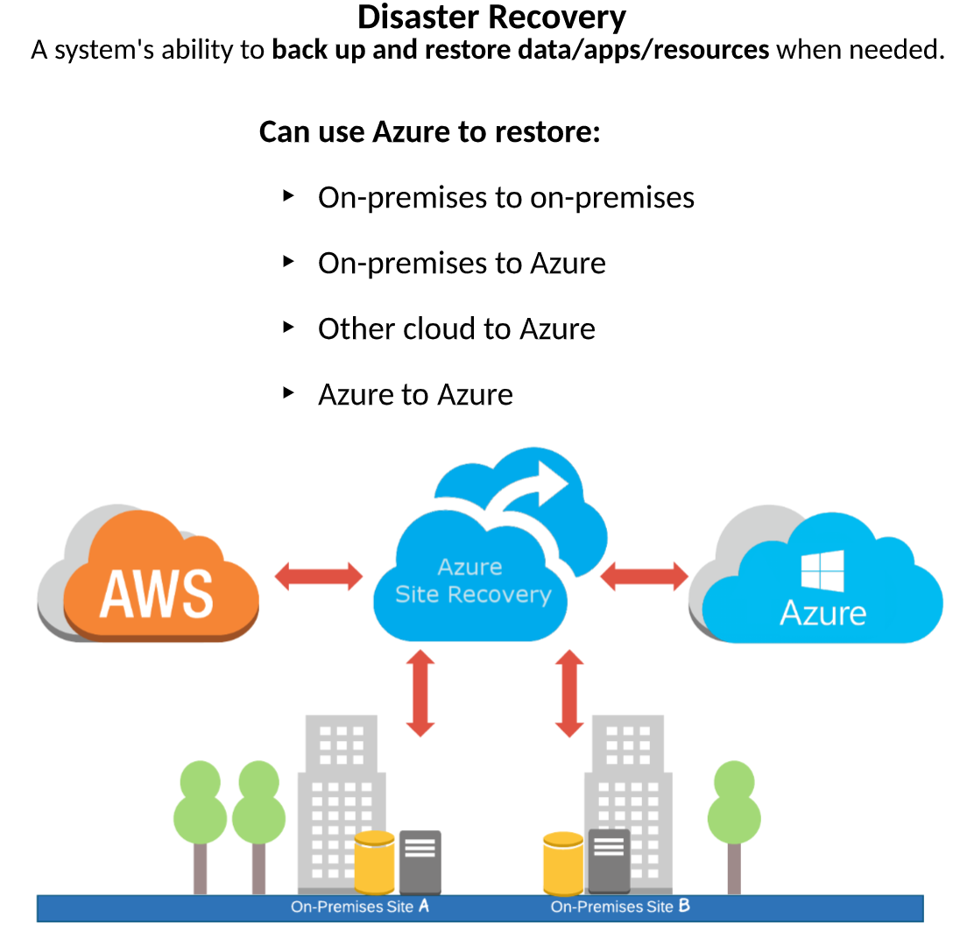

* 1. When a disaster does strike, we have the available options we need in order to restore our services and get them back up and running